At the Station: What to Expect When Making a Statement
A Guide by Safe and Sane NZ
1. The First Step: The Front Counter
When you walk in, you will speak to the staff at the front desk.
- What to say: "I am here to make a formal statement about family harm."
- What happens: They will find a private room for you to wait in. You don’t have to sit in the public waiting area.
- Your Rights: You can ask for a Family Harm Specialist officer or a female officer if that makes you feel more comfortable.
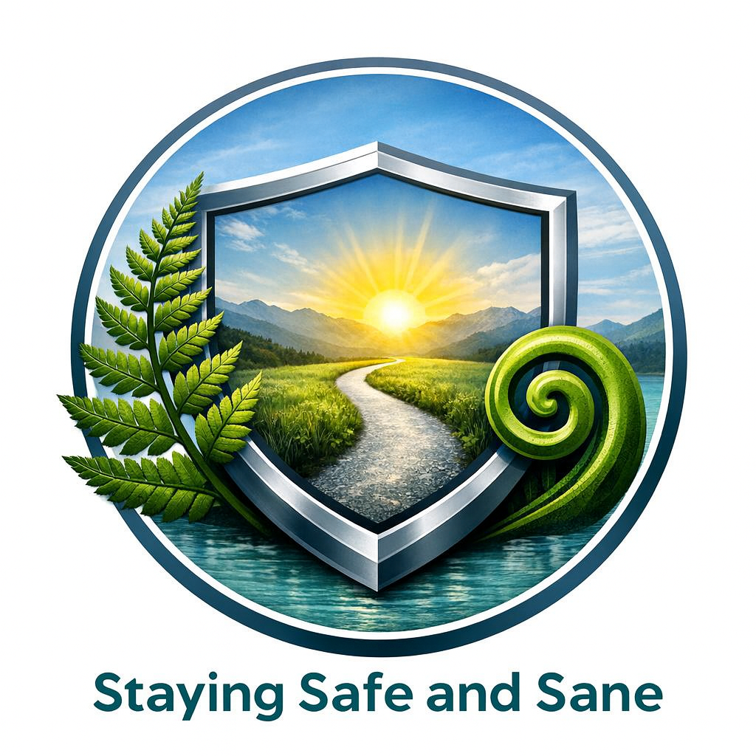
2. The Interview: Telling Your Story
A statement isn't a "test"; it’s an interview. An officer will sit with you in a private room to record what has been happening.
- The Format: They will ask you to tell your story from the beginning. They will take notes or type as you speak.
- Be Specific: It’s okay if you don’t remember exact dates. Use "anchors" like, "It was around my daughter's birthday," or "It was the weekend of the big storm."
- Include the "Fog": Tell them about the threats, the stalking, and the controlling behavior (like checking your phone)—not just the physical hits.
3. Support: You Don't Have to Do This Alone
You are legally allowed to have a person support you. This could be:
- A trusted friend or whānau member.
- An advocate from Women’s Refuge or other family violence agencies.
- A lawyer.
- Note: Your support person is there for emotional comfort, but they cannot "answer" the questions for you.

4. Reviewing the Statement
Once the officer has finished typing, they will ask you to read through the document.
- Check the details: If something isn't quite right, or if they used a word you didn't say, speak up. It is your statement, and it needs to be 100% your truth.
- The Signature: Once you are satisfied, you will sign it. This turns the document into a "Sworn Statement," which means it is now a powerful legal tool.
5. After the Statement: Immediate Protection
Before you leave, ask the officer about Police Safety Orders.
- Police Safety Order (PSO): The Police can issue a PSO on the spot, which can order the abuser to leave the house and stay away from you for up to 10 days. This gives you "breathing room" to apply for a long-term Protection Order.

