PREP SHEET: Organizing Your Truth
For use with NZ Police | Tool by Safe and Sane NZ
Fill this out before you go to the station. You can bring this sheet into the interview room with you. It is not your formal statement; it is your memory anchor.
1. The "Big Three" Incidents
Don't worry about every single argument. Focus on the three most serious or most recent events.
- Incident 1: (Date/Time/What happened?) __________________________________________________________________________
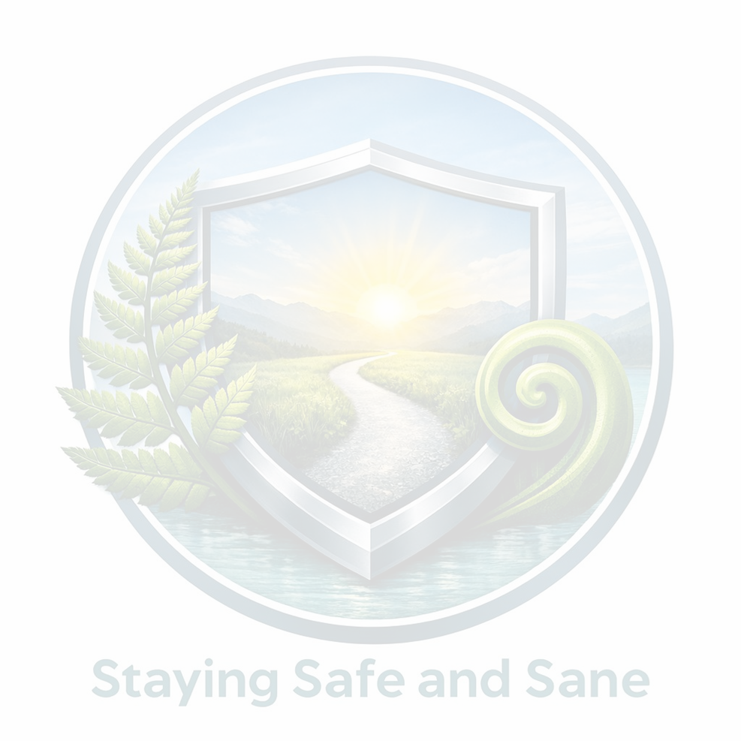
- Incident 2: (Date/Time/What happened?) __________________________________________________________________________
- Incident 3: (Date/Time/What happened?) __________________________________________________________________________
2. High-Risk Indicators (Tick any that apply)
Identifying these helps the Police understand the urgency of your safety.
- [ ] Strangulation: Have they ever put hands on your neck or "choked" you?
- [ ] Weapons: Have they used or threatened you with an object (knife, tool, etc.)?
- [ ] Stalking: Have they followed you or shown up at your work/supermarket?
- [ ] Digital Control: Do they track your phone or demand your passwords?
- [ ] Suicide Threats: Do they threaten to hurt themselves to stop you from leaving?
3. The Impact on the Whānau
Where were the children during these events?
- [ ] They were in the room.
- [ ] They were in the next room/heard it through the walls.
- [ ] They were physically hurt or threatened.
- [ ] They were used to "spy" on me or relay messages.
4. Evidence Log (What do you have on your phone?)
List the specific things you can show the officer today.
- Photos of: (Bruises, broken property, holes in walls) __________________________
- Texts/Emails from: (Dates/Times of abusive messages) __________________________
- CCTV/Ring Footage: (Description of the video) ________________________________
5. Your Tactical Goal
What do you need the Police to help you with today? (Tick your priorities)
- [ ] I need a Police Safety Order (PSO) to get them out of the house for a few days.

- [ ] I want to apply for a long-term Protection Order.
- [ ] I want them to be charged with a crime.
- [ ] I just want this documented so there is a "paper trail" for the future.

A Message from, Safe and Sane NZ:
"You are not 'making trouble' by telling the truth. You are creating a record that protects your future and your children's future. Take a deep breath. You've got this."

