Statutory Declaration Template
Notice to User: Do not sign this until you are standing in front of an authorized witness (like a JP, Lawyer, or Court Registrar).
I, [Full Name] of [Current Residential Address] occupation [Your Job Title or 'Stay-at-home parent', 'Student', etc.]
solemnly and sincerely declare that:
- I am a tenant at the property located at [Address of the Rental Property].
- I have been a victim of family violence/family harm while a tenant at this property.
- This violence/harm was inflicted by [Optional: Name of person/relationship to you, e.g., 'my partner'—Note: You are not legally required to name them for a tenancy withdrawal, but the form asks for confirmation that violence occurred].
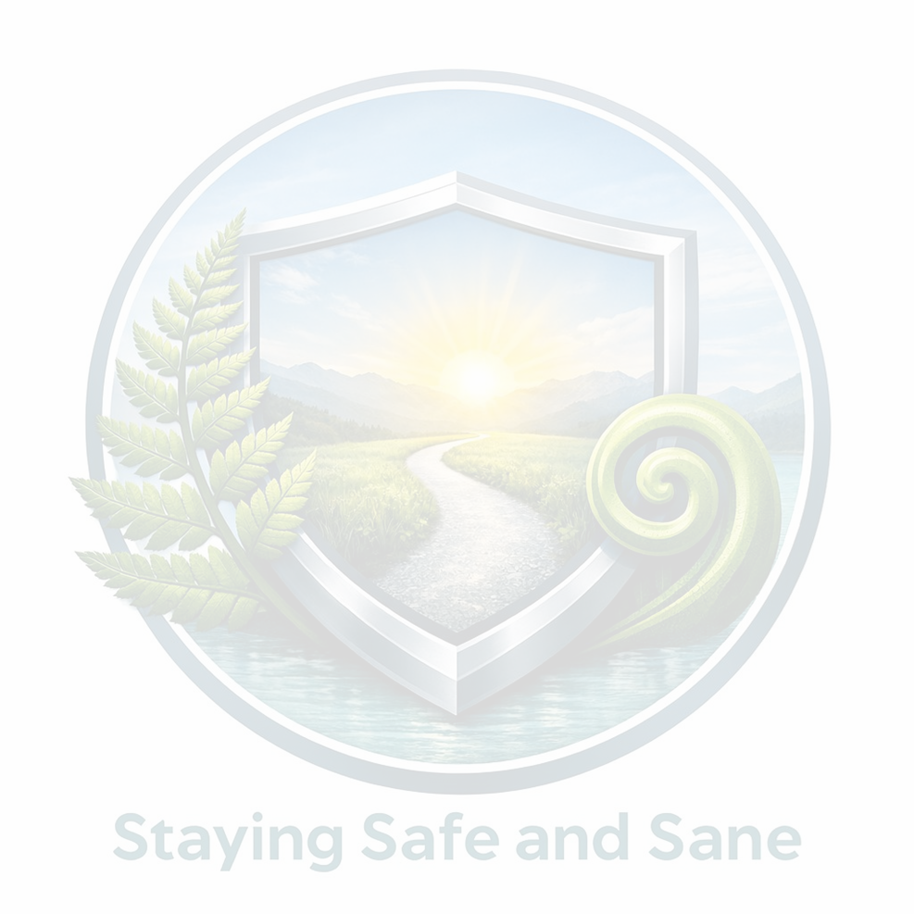
- I am providing this declaration as qualifying evidence under Section 56B of the Residential Tenancies Act 1986 to withdraw from my tenancy agreement.
- I make this solemn declaration conscientiously believing the same to be true and by virtue of the Oaths and Declarations Act 1957.

Signature of Declarant: _________________________________________ (Your signature - Sign this ONLY in front of the witness)
Declared at: [City/Town, e.g., Waitakere] this [Date] day of [Month], 20[Year]
Before me: _________________________________________ (Signature of Witness)
Full Name of Witness: _________________________________________ Title of Witness: [e.g., Justice of the Peace / Solicitor of the High Court]

.

