TOOLKIT: Documenting Identity-Based Abuse
Subtitle: Building Your Case for the Family Court (Rainbow Community Focus).

1. The Legal Definitions (Aotearoa 2026)
To get a Protection Order, you must show that there is a pattern of behavior that causes you harm or makes you fear for your safety. Identity abuse is often "invisible" to people outside the community, so you must be specific in your documentation.
Examples of Psychological Abuse in the Rainbow Context:
- Weaponized Outing: "If you leave, I’m telling your conservative parents/employer that you’re gay/trans."
- Medical Interference: Hiding, destroying, or controlling access to HRT (Hormone Replacement Therapy) or PrEP.
- Deadnaming/Misgendering: Repeatedly and intentionally using your former name or wrong pronouns to cause distress or "break" your sense of self.
- Community Shaming: Threatening to tell the community you are "predatory" or "not queer enough" to isolate you.

2. The Evidence Log (Fill-In Worksheet)
When documenting, don't just record what they did; record how it made you feel and how it restricted your freedom.
Date/Time | What was said/done? | Impact on You | Evidence? (Texts/Audio/Witness)
Example | Threatened to tell my boss I'm HIV+. | I felt sick and terrified of losing my job. | 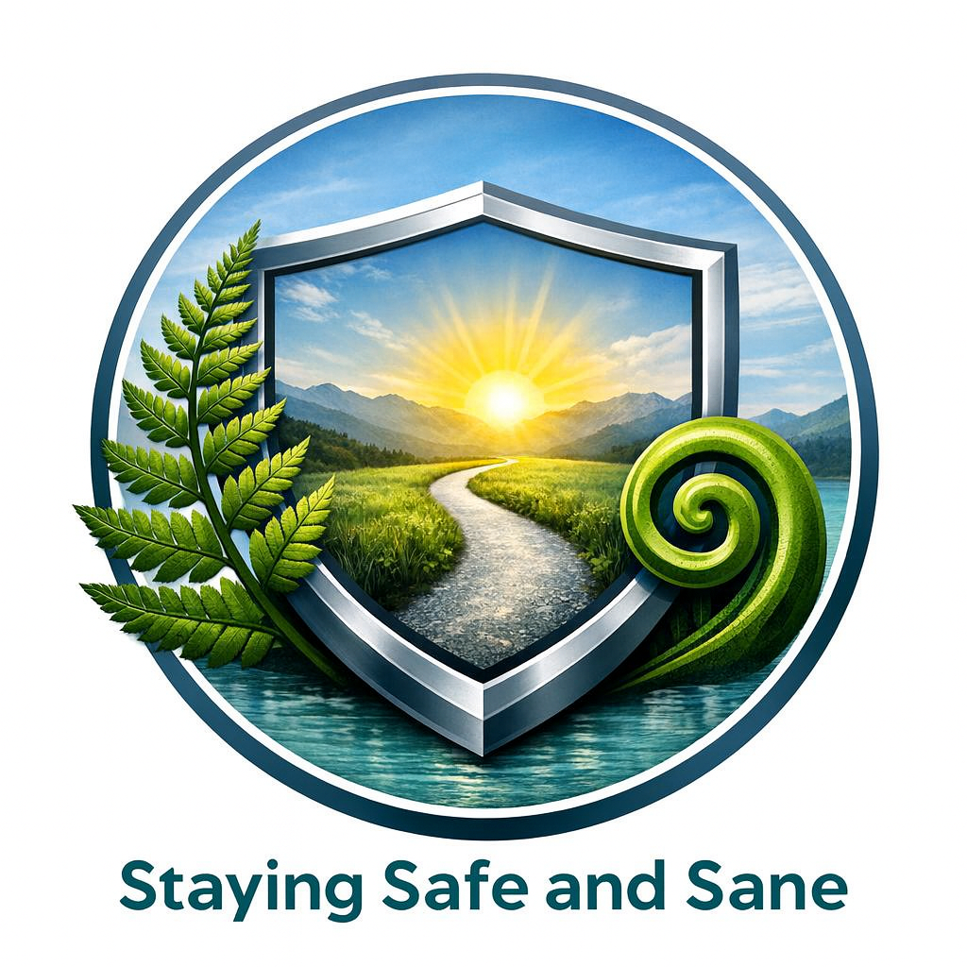  Screenshot of the text message.

3. Drafting Your Affidavit (The "Sanity" Scripts)
When writing your statement for a lawyer or the Court, use these structures to ensure the judge understands the severity of identity-based harm:
- On Weaponized Outing: "The respondent knows that my family/employer is not aware of my identity. By threatening to reveal this, they are leveraging my livelihood and safety against me to keep me in the relationship."
- On Medical Coercion: "By withholding my medication/binders, the respondent is exercising physical control over my body and causing significant mental and physical distress."
- On Isolation: "The respondent tells me that because I am [Identity], no mainstream refuge or police officer will help me. This has made me feel trapped and without any support system."

4. Safety Note: Digital Evidence
If the abuse is happening via apps (Grindr, Scruff, Lex, etc.), remember that messages can be "unsent" or accounts deleted by the abuser.
- Screenshot everything.
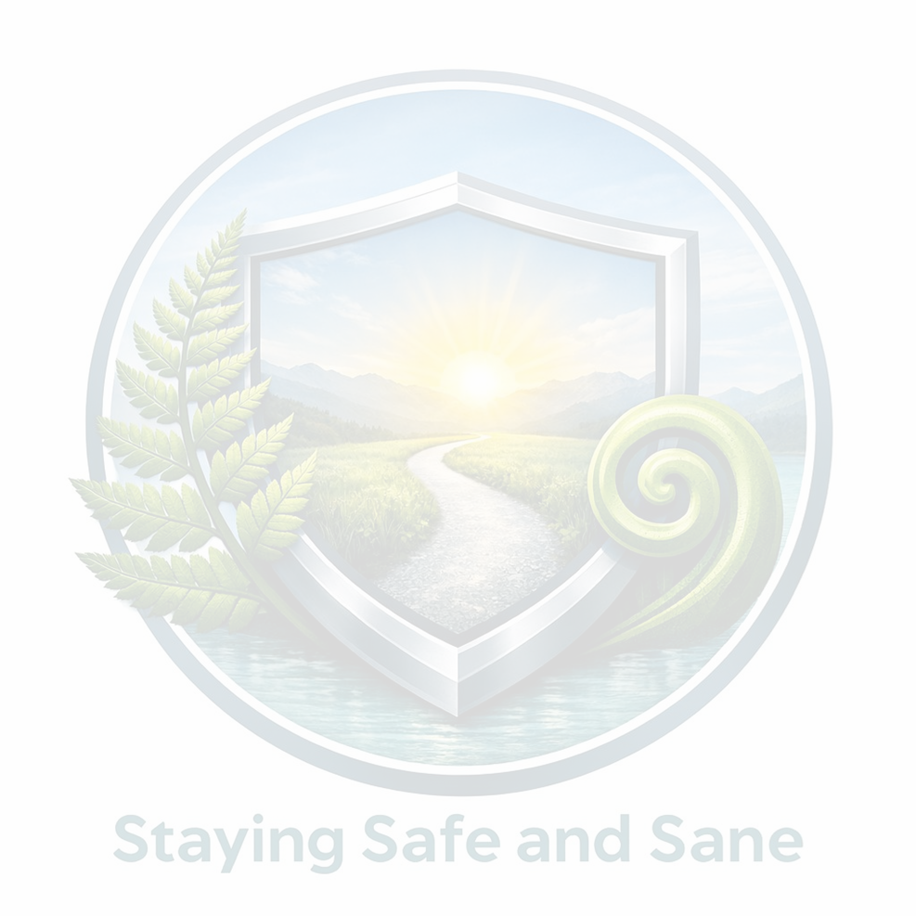
- Save to a hidden "Vault" app or a separate email address your partner doesn't know about.
- Record the "UID" (User ID): If they delete their profile, having a screenshot of their profile ID can help the Police track the account later.

5. Your "Sanity Anchor"
"My identity is not a weapon to be used against me. The law in New Zealand protects me regardless of my gender, my sexuality, or how 'out' I am. I am entitled to a life free from threats.".

